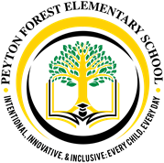

Pre-Kindergarten School Supply List

2022 - 2023

Pack of sharpened pencils

2 packages of crayons

2 large glue sticks

2 small glue sticks

2 sets of clothes with underwear

1 small blanket for nap time

1 full-sized book bag (no wheels)

2 Primary Notebooks

Pack of Dry Erase Markers

Pack of Erasers

Appreciated donations:

3 boxes of tissue Disinfectant Wipes and Spray

2 rolls of paper towels Classroom Snacks and Drinks (nut-free)

Ziploc bags (sandwich/quart/or gallon) Cases of bottled water